Lab Assignment 2.3: Exploring Additional AI Coding Tools – Gemini (Colab) and Cursor AI
Name: Suvikhyath Thirunahari
Program: M. Tech
Roll No.: 2503B05202
Course Title: AI Assisted Problem Solving Using Python
Date: 02-11-2025
Objective
The objective of this lab is to explore AI-powered coding assistants beyond GitHub Copilot. Students will use Google Gemini in Colab and Cursor AI to generate, explain, and refactor Python code. The goal is to compare the capabilities of these tools in terms of code generation, explanation clarity, optimization, and usability.

Lab Outcomes (LOs)
After completing this lab, students will be able to:
- Generate Python code using Google Gemini in Google Colab.
- Analyze the effectiveness of Gemini’s explanations and suggestions.
- Set up and use Cursor AI for AI-powered code generation and refactoring.
- Refactor and improve Python code using AI assistance.
- Compare usability and output quality across Gemini, Copilot, and Cursor AI.

Task 1: Using Google Gemini in Colab to Read CSV and Compute Mean, Min, Max
Prompt to use in Gemini:
Write a Python function that reads a CSV file and returns the mean, minimum, and maximum of a numerical column.
Code Example:
import pandas as pd
def analyze_csv(file_path, column_name):
df = pd.read_csv(file_path)
mean_val = df[column_name].mean()
min_val = df[column_name].min()
max_val = df[column_name].max()
return mean_val, min_val, max_val
# Example usage:
# analyze_csv('data.csv', 'sales')
Expected Output:Display of mean, min, and max values in Colab output cell.
Screenshots:
- Gemini interface showing code generation
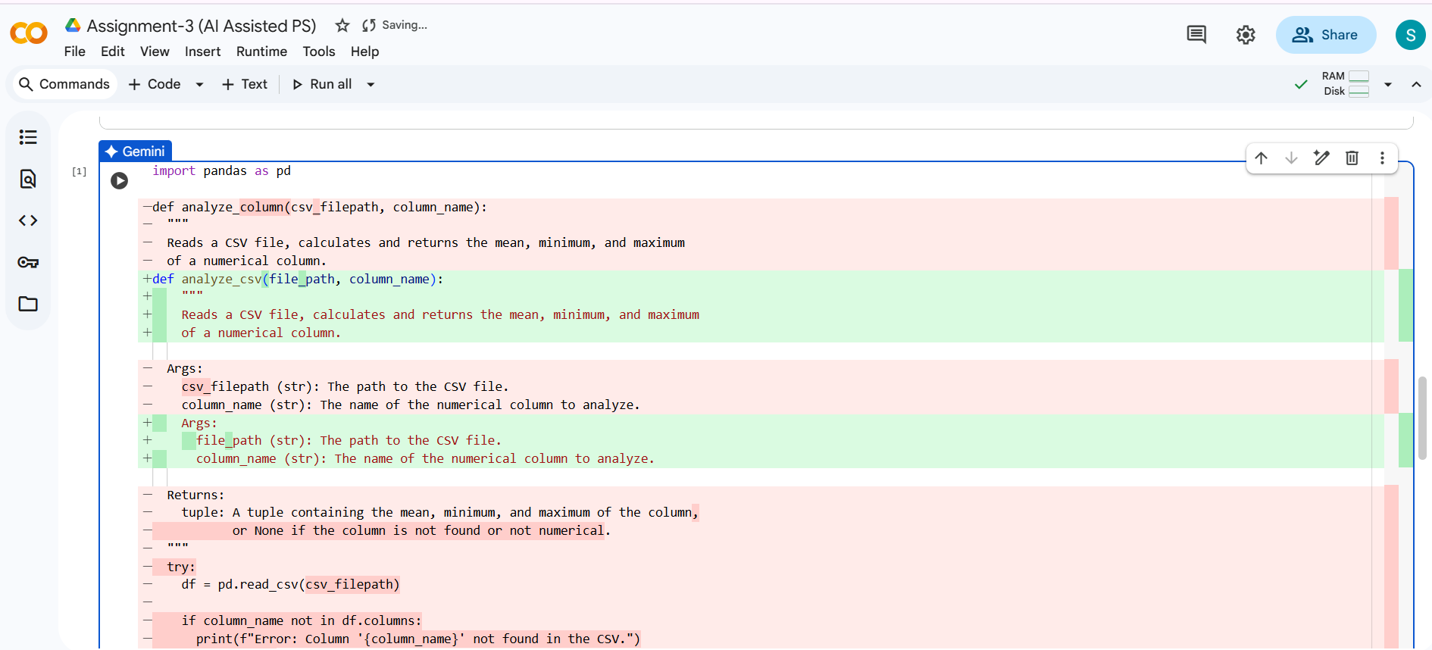
- Output cell in Colab
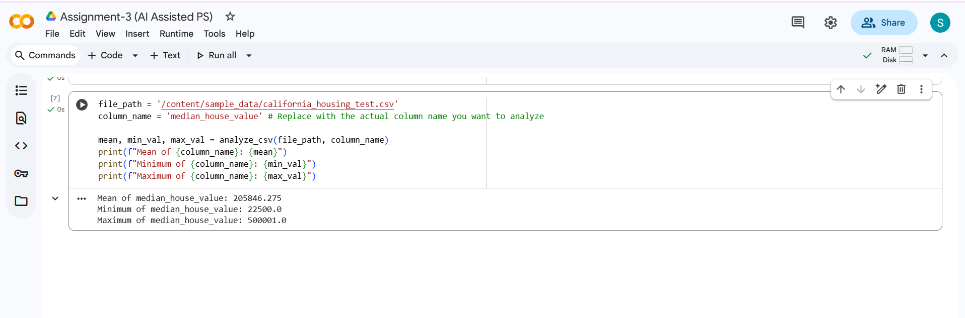

Task 2: Comparing Gemini and Copilot Outputs for Palindrome Function
Task Description: Compare Gemini and GitHub Copilot outputs for a function that checks if a string is a palindrome.
Prompts:
Gemini: 'Write a Python function to check if a string is a palindrome.'
Copilot: 'Function to check if a string is palindrome'
Example Output:
def is_palindrome(s):
s = s.lower().replace(" ", "")
return s == s[::-1]
Screenshots:
- Gemini output
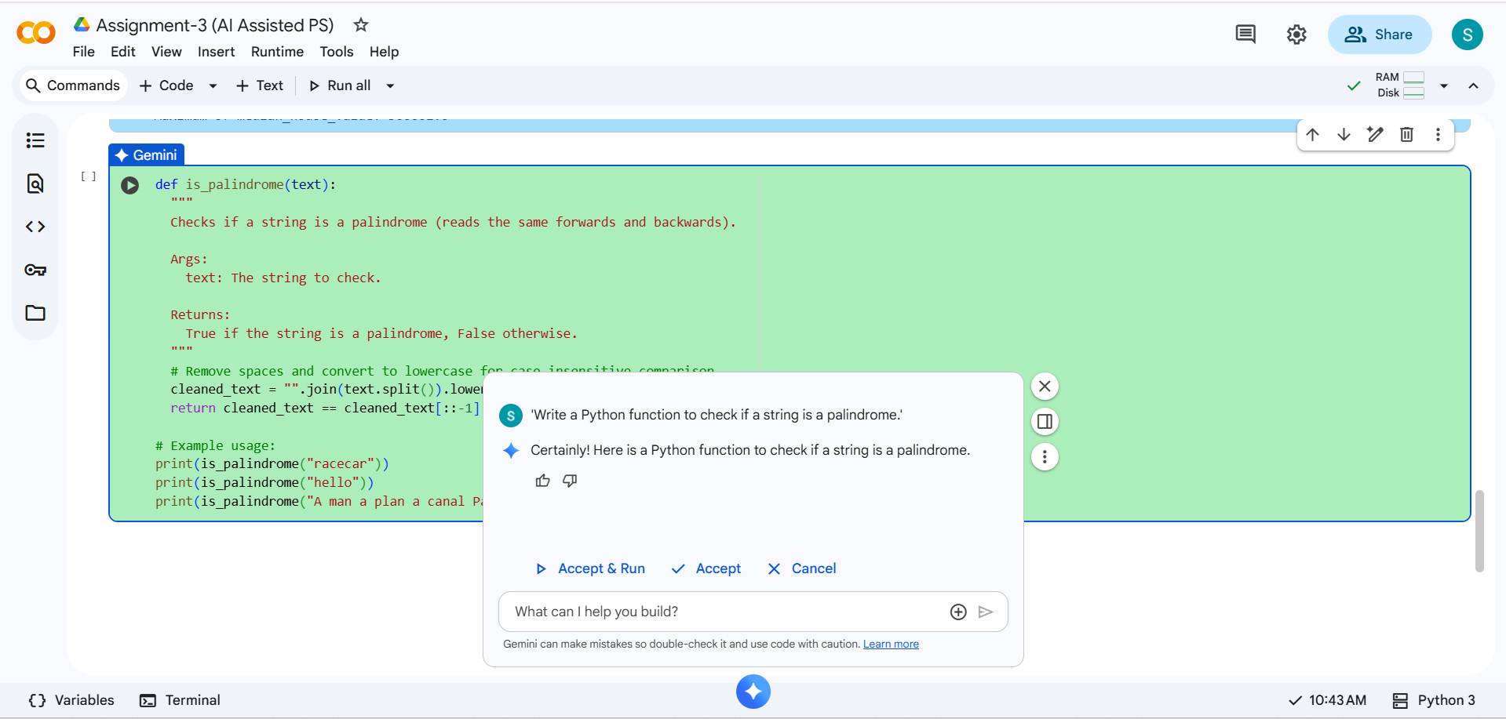
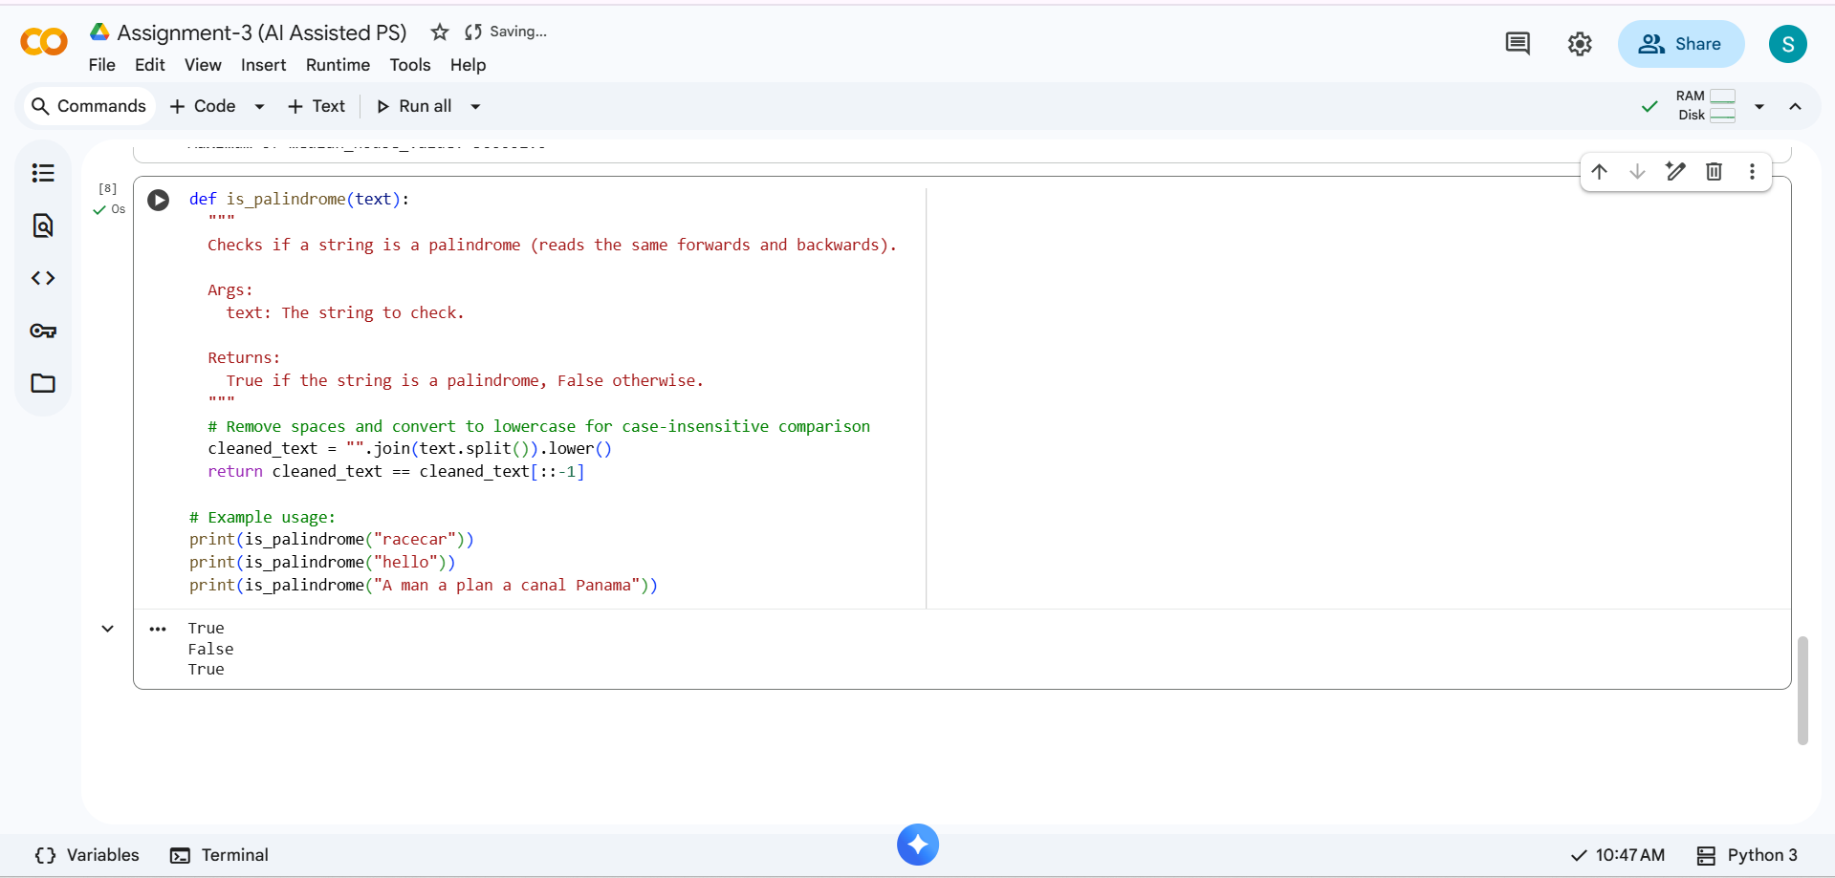
-Copilot output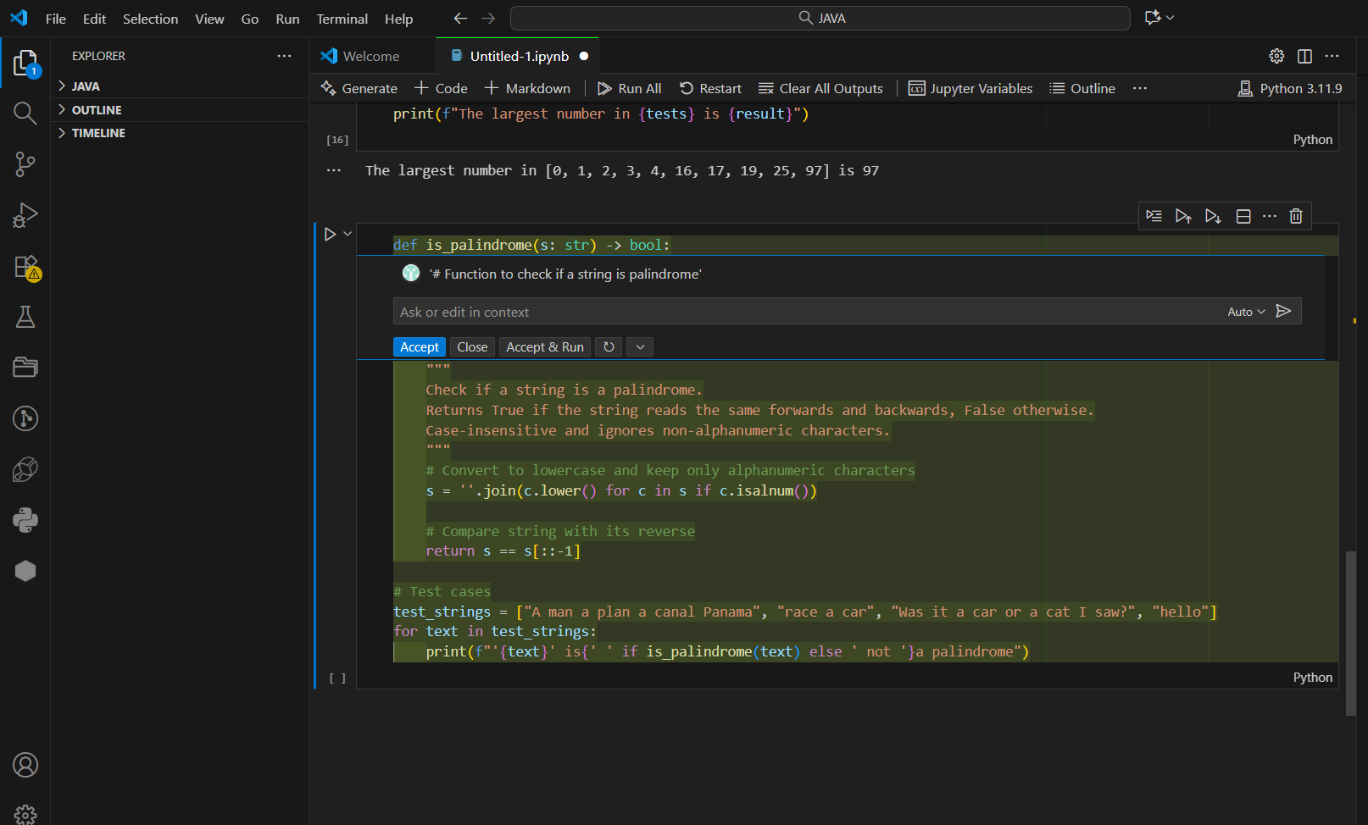
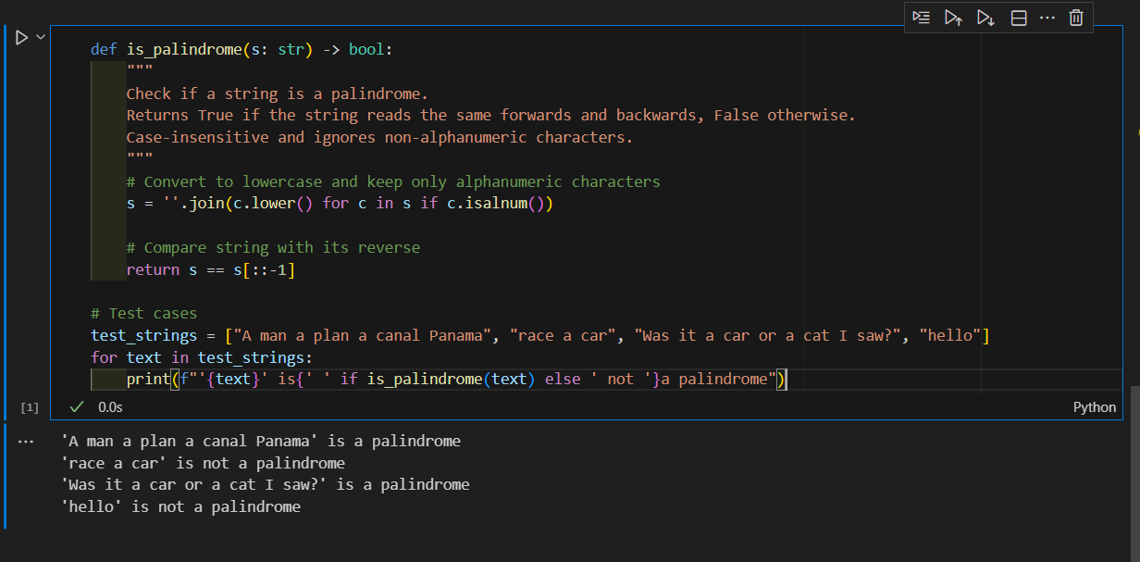

Task 3: Ask Gemini to Explain Code Line by Line
Task Description: Ask Gemini to explain a Python function that calculates the area of various shapes.
Prompt: 'Explain this Python function line by line that calculates the area of various shapes.
Example Function:
def area(shape, **kwargs):
if shape == "circle":
return 3.1416 * (kwargs["radius"] ** 2)
elif shape == "rectangle":
return kwargs["length"] * kwargs["width"]
elif shape == "triangle":
return 0.5 * kwargs["base"] * kwargs["height"]
Screenshots:
- Gemini explanation response
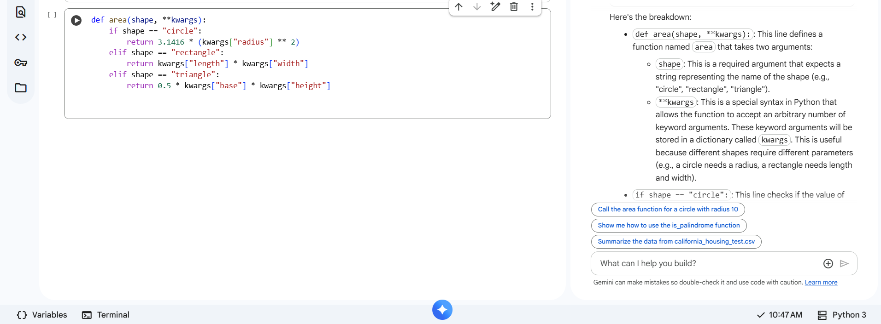

- Original code cell
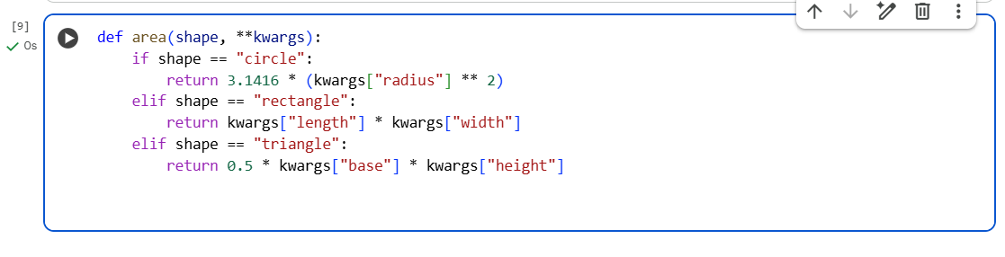

Task 4: Installing and Using Cursor AI for Code Generation
Task Description: Install Cursor AI, then use it to generate a Python function such as calculating the sum of squares of numbers in a list.
Prompt to use in Cursor: '# Function to calculate sum of squares in a list'
Expected Output Example:
def sum_of_squares(numbers):
return sum(n ** 2 for n in numbers)
Steps to Document:
- 1. Install Cursor AI from https://cursor.sh and sign in.
- 2. Open Cursor and create a new Python file.
- 3. Type the given prompt comment and observe AI-generated code.
- 4. Run the code to verify correctness.
Screenshots :

Task 5: Refactor Code to Calculate Sum of Odd and Even Numbers
Task Description: Write code to calculate the sum of odd and even numbers in a list, refactoring or improving logic suggested by AI tools.
Prompt Example:'# Function to calculate sum of odd and even numbers separately'
Sample Refactored Code:
def sum_odd_even(numbers):
odd_sum = sum(n for n in numbers if n % 2 != 0)
even_sum = sum(n for n in numbers if n % 2 == 0)
return odd_sum, even_sum
Output: For input [1, 2, 3, 4, 5], output should be Odd Sum = 9, Even Sum = 6.
Screenshots :
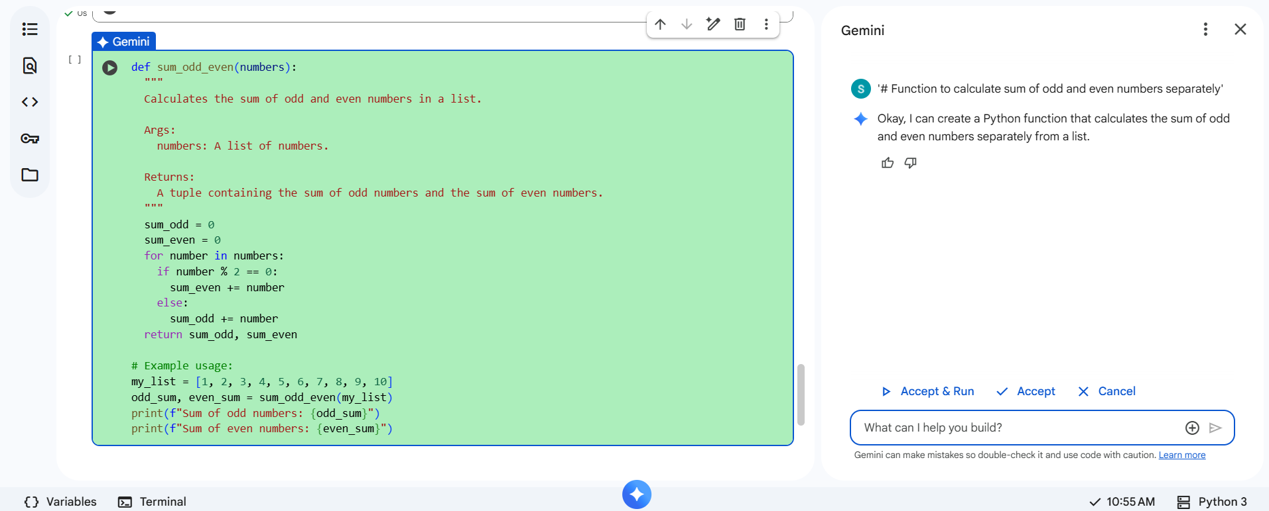
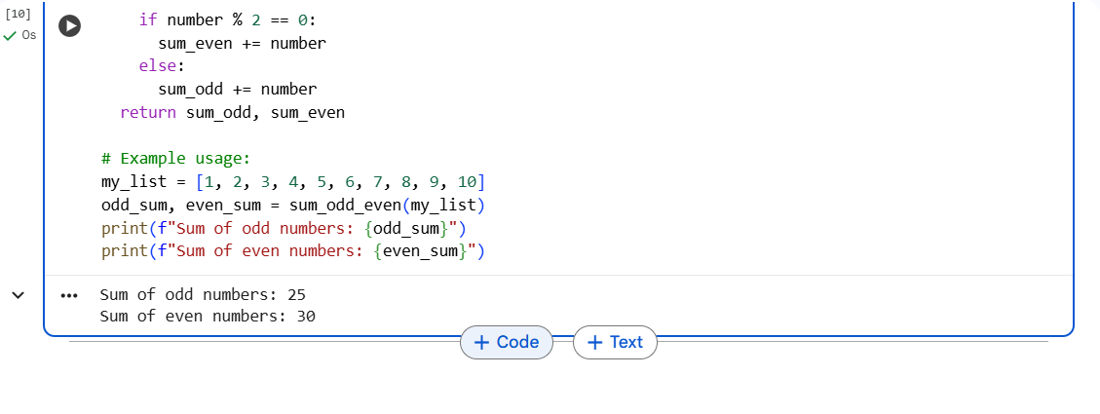

Conclusion
This lab enabled practical exposure to multiple AI-assisted coding tools. Google Gemini demonstrated strong capabilities in code explanation and structured generation within Colab, while Cursor AI provided fast, on-device refactoring and code suggestions. Comparing these tools against Copilot highlighted their different strengths in usability, accuracy, and productivity enhancement.

